**Design & Technology**

**

**Metal finishing**

**Materials required for questions**

* Pencil
* Rubber
* Calculator

**Instructions**

* Use black ink or ball-point pen
* Try answer all questions
* Use the space provided to answer questions
* Calculators can be used if necessary
* For the multiple choice questions, circle your answer

**Advice**

* Marks for each question are in brackets
* Read each question fully
* Try to answer every question
* Don’t spend too much time on one question

**Good luck!**

**Q1.** Which metal finish involves applying a liquid paint that hardens upon exposure to air?

**A** Powder coating

**B** Cellulose paint

**C** Electro-plating

**Q2.** What is the purpose of galvanising a metal?

**A** To make it more flexible

**B** To prevent corrosion by applying a zinc layer

**C** To give it a shiny appearance

**Q3.** Which finishing process uses an electric current to deposit a metal coating?

**A** Dip coating

**B** Powder coating

**C** Electro-plating

**Q4.** What is the main purpose of using sealants on metals?

**A** To provide a waterproof barrier

**B** To increase electrical conductivity

**C** To change the metal’s colour

**Q5.** Explain why anodising is an appropriate finish for an aluminium torch **(6 marks**

**Q6.** Explain why galvanising is an appropriate finish for the low carbon steel scaffold shown below **(6 marks)**

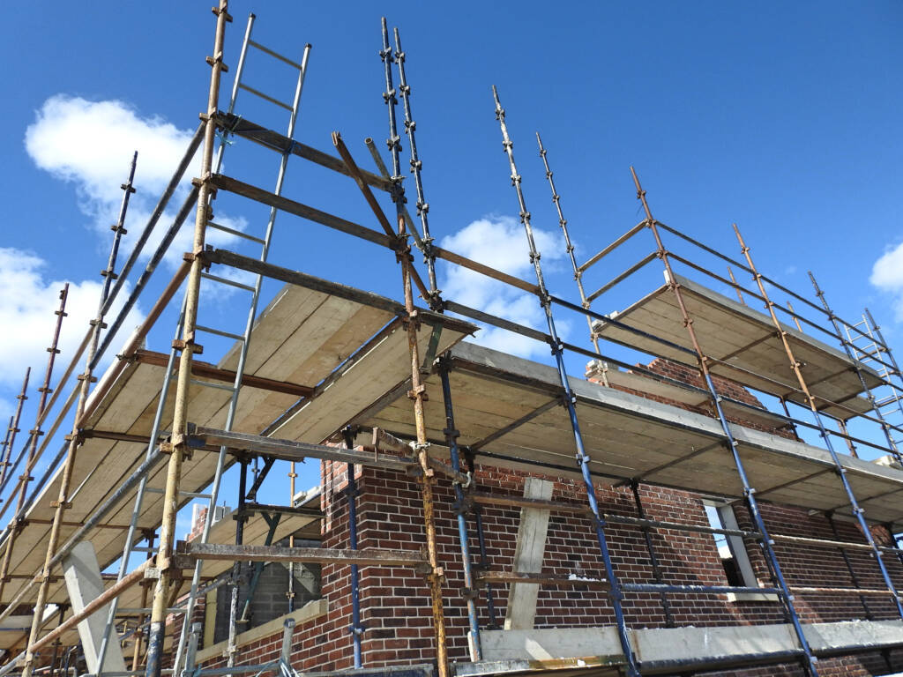

**Q7.** Give three reasons why a product may have an anodised finish **(3 marks)**

1.

2.

3.

**Q8**. Explain why powder coating is an appropriate finish for the climbing frame shown below **(6 marks)**

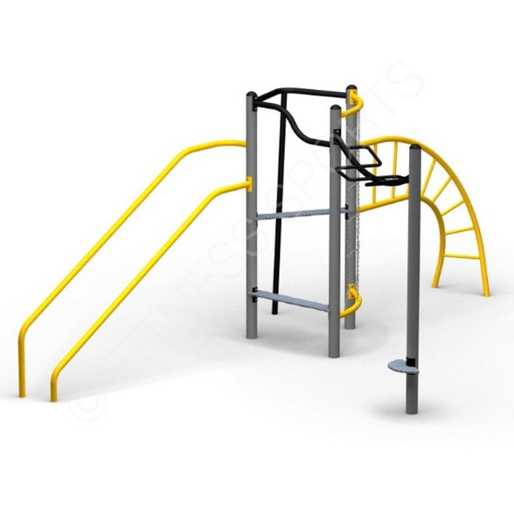

**Answers**

**Q1**. B

**Q2**. B

**Q3**. C

**Q4**. A

**Q5.**

* The anodising enhances the natural oxide layer of the aluminium, increasing its hardness and toughness, allowing for the torch to resist scratching and wear associated with storage and use.
* The anodising process allows for a pigment or colour to be used which enhances the aesthetic of the torch.
* An anodised finish can be laser etched to allow the text and logos to be added to the torch, using the natural colour of the aluminium to provide clear contrast.
* Anodising protects the aluminium from further corrosion or oxidisation.
* Anodising is an electroplating process which ensures that all surfaces of the components of the torch are evenly anodised.
* The thickness of the anodised coating is minimal which therefore doesn’t affect any threaded components, or interfere with the knurled surface of the torch handle.
* The anodised finish is tough and hardwearing, requiring no maintenance during the lifespan of the torch.

**Q6.**

* The scaffold is a functional object, where aesthetics are not as important as function therefore the inconsistent galvanised patterned finish causes no issue.
* Galvanising protects the low carbon steel from corrosion. The galvanising process is hardwearing so will resist the scratching likely to occur from assembly, storage and transportation.
* The cathodic protective nature of galvanising means that the scaffold would continue to be protected even if damage did occur.
* The dip coating nature of galvanising means that the hollow steel structure of the scaffold is protected on all surfaces.
* Galvanising provides a zinc protective layer to the low carbon steel which provides cathodic protection for the base metal.
* Galvanising provides a surface finish that requires little or no maintenance allowing for extend use and reducing any ongoing costs to the scaffold user.

**Q7.**

* Anodising can increase the resistance to corrosion.
* Anodising can be used to add a pigment, colour, or decorative surface finish.
* Anodising increases the hardness of the aluminium product’s surface.
* Anodising increases the toughness of the aluminium product’s surface.
* Anodising can increase the resistance to wear when in contact with other materials

**Q8.**

* Powder coating provides a hard, durable finish which will resist the wear from children’s shoes.
* Thicker coats can be achieved than feasible with liquid paint finishes.
* A wide range of colours are available, as pigments can be added.
* Powder coating will protect the frame from oxidising.
* Powder coating gives an even coat of material around cylindrical shapes.
* Overspray from the climbing frame can be recycled and reused.
* Powder coated finishes are less prone to fading from UV degradation due to the use of stabilisers.
* Powder coated finishes are less likely to chip than traditional paint finishes.
* Powder coated finishes are not affected by extremes of temperature found outdoors during summers and winters.